School Counseling Employer Survey - fall 2020
2017-2019 Graduates (66 graduates) (29 employed as School Counselors – 11 responses – 38% return rate)
Q1 - Overall job performance
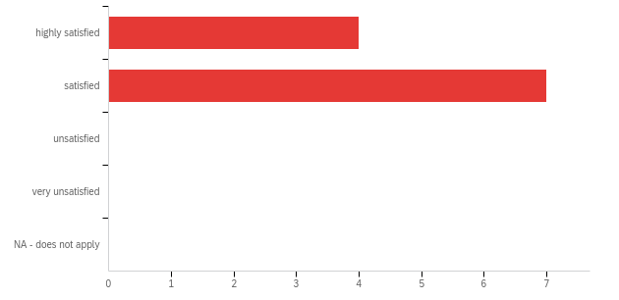

# | Field | Minimum | Maximum | Mean | Std Deviation | Variance | Count
1 | Overall job performance | 1.00 | 2.00 | 1.64 | 0.48 | 0.23 | 11

# | Answer | % | Count
1 | highly satisfied | 36.36% | 4
2 | satisfied | 63.64% | 7
3 | unsatisfied | 0.00% | 0
4 | very unsatisfied | 0.00% | 0
5 | NA - does not apply | 0.00% | 0
 | Total | 100% | 11

Q2 - Individual counseling skills

# | Field | Minimum | Maximum | Mean | Std Deviation | Variance | Count
1 | Individual counseling skills | 1.00 | 2.00 | 1.64 | 0.48 | 0.23 | 11

# | Answer | % | Count
1 | highly satisfied | 36.36% | 4
2 | satisfied | 63.64% | 7
3 | unsatisfied | 0.00% | 0
4 | very unsatisfied | 0.00% | 0
5 | NA - does not apply | 0.00% | 0
 | Total | 100% | 11

Q3 - Group counseling skills
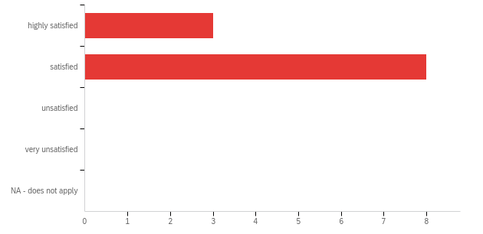

# | Field | Minimum | Maximum | Mean | Std Deviation | Variance | Count
1 | Group counseling skills | 1.00 | 2.00 | 1.73 | 0.45 | 0.20 | 11

# | Answer | % | Count
1 | highly satisfied | 27.27% | 3
2 | satisfied | 72.73% | 8
3 | unsatisfied | 0.00% | 0
4 | very unsatisfied | 0.00% | 0
5 | NA - does not apply | 0.00% | 0
 | Total | 100% | 11

Q4 - Psychoeducational (structured ) group skills
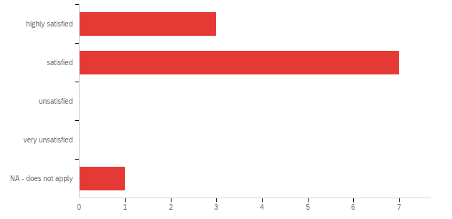

# | Field | Minimum | Maximum | Mean | Std Deviation | Variance | Count
1 | Psychoeducational (structured ) group skills | 1.00 | 5.00 | 2.00 | 1.04 | 1.09 | 11

# | Answer | % | Count
1 | highly satisfied | 27.27% | 3
2 | satisfied | 63.64% | 7
3 | unsatisfied | 0.00% | 0
4 | very unsatisfied | 0.00% | 0
5 | NA - does not apply | 9.09% | 1
 | Total | 100% | 11

Q5 - Multicultural counseling skills
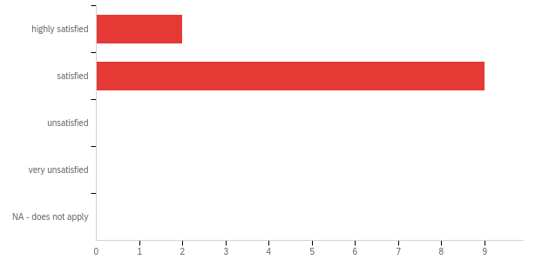

# | Field | Minimum | Maximum | Mean | Std Deviation | Variance | Count
1 | Multicultural counseling skills | 1.00 | 2.00 | 1.82 | 0.39 | 0.15 | 11

# | Answer | % | Count
1 | highly satisfied | 18.18% | 2
2 | satisfied | 81.82% | 9
3 | unsatisfied | 0.00% | 0
4 | very unsatisfied | 0.00% | 0
5 | NA - does not apply | 0.00% | 0
 | Total | 100% | 11

Q6 - Career/lifestyle counseling skills
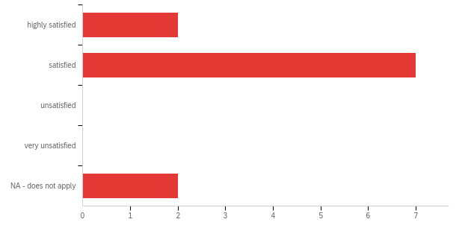

# | Field | Minimum | Maximum | Mean | Std Deviation | Variance | Count
1 | Career/lifestyle counseling skills | 1.00 | 5.00 | 2.36 | 1.30 | 1.69 | 11

# | Answer | % | Count
1 | highly satisfied | 18.18% | 2
2 | satisfied | 63.64% | 7
3 | unsatisfied | 0.00% | 0
4 | very unsatisfied | 0.00% | 0
5 | NA - does not apply | 18.18% | 2
 | Total | 100% | 11

Q7 - Classroom guidance
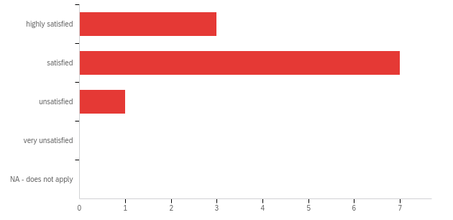

# | Field | Minimum | Maximum | Mean | Std Deviation | Variance | Count
1 | Classroom guidance | 1.00 | 3.00 | 1.82 | 0.57 | 0.33 | 11

# | Answer | % | Count
1 | highly satisfied | 27.27% | 3
2 | satisfied | 63.64% | 7
3 | unsatisfied | 9.09% | 1
4 | very unsatisfied | 0.00% | 0
5 | NA - does not apply | 0.00% | 0
 | Total | 100% | 11

Q8 - Crisis counseling skills
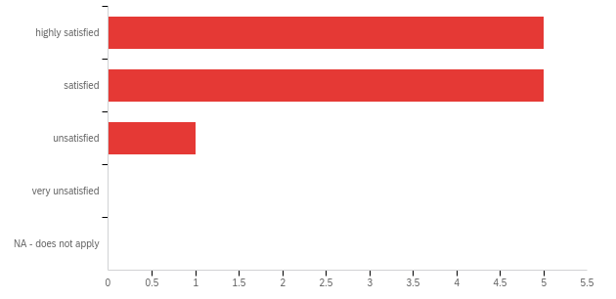

# | Field | Minimum | Maximum | Mean | Std Deviation | Variance | Count
1 | Crisis counseling skills | 1.00 | 3.00 | 1.64 | 0.64 | 0.41 | 11

# | Answer | % | Count
1 | highly satisfied | 45.45% | 5
2 | satisfied | 45.45% | 5
3 | unsatisfied | 9.09% | 1
4 | very unsatisfied | 0.00% | 0
5 | NA - does not apply | 0.00% | 0
 | Total | 100% | 11

Q9 - Play therapy skills
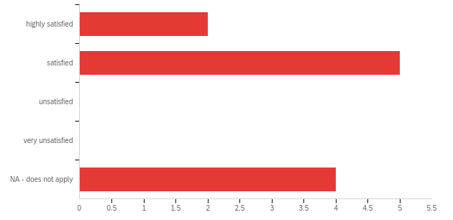

# | Field | Minimum | Maximum | Mean | Std Deviation | Variance | Count
1 | Play therapy skills | 1.00 | 5.00 | 2.91 | 1.62 | 2.63 | 11

# | Answer | % | Count
1 | highly satisfied | 18.18% | 2
2 | satisfied | 45.45% | 5
3 | unsatisfied | 0.00% | 0
4 | very unsatisfied | 0.00% | 0
5 | NA - does not apply | 36.36% | 4
 | Total | 100% | 11

Q10 - Child and adolescent counseling skills
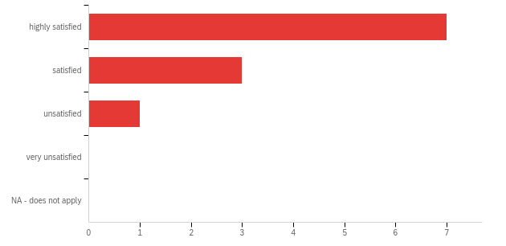

# | Field | Minimum | Maximum | Mean | Std Deviation | Variance | Count
1 | Child and adolescent counseling skills | 1.00 | 3.00 | 1.45 | 0.66 | 0.43 | 11

# | Answer | % | Count
1 | highly satisfied | 63.64% | 7
2 | satisfied | 27.27% | 3
3 | unsatisfied | 9.09% | 1
4 | very unsatisfied | 0.00% | 0
5 | NA - does not apply | 0.00% | 0
 | Total | 100% | 11

Q11 - Human growth and development skills
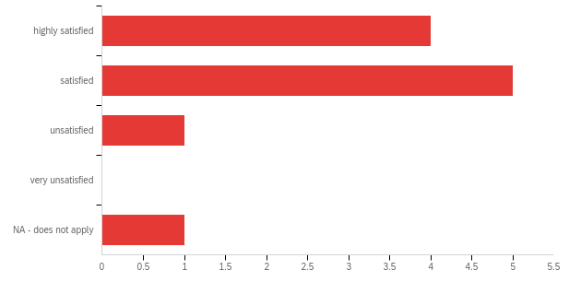

# | Field | Minimum | Maximum | Mean | Std Deviation | Variance | Count
1 | Human growth and development skills | 1.00 | 5.00 | 2.00 | 1.13 | 1.27 | 11

# | Answer | % | Count
1 | highly satisfied | 36.36% | 4
2 | satisfied | 45.45% | 5
3 | unsatisfied | 9.09% | 1
4 | very unsatisfied | 0.00% | 0
5 | NA - does not apply | 9.09% | 1
 | Total | 100% | 11

Q12 - Assessment/appraisal/testing skills

# | Field | Minimum | Maximum | Mean | Std Deviation | Variance | Count
1 | Assessment/appraisal/testing skills | 1.00 | 3.00 | 1.82 | 0.57 | 0.33 | 11

# | Answer | % | Count
1 | highly satisfied | 27.27% | 3
2 | satisfied | 63.64% | 7
3 | unsatisfied | 9.09% | 1
4 | very unsatisfied | 0.00% | 0
5 | NA - does not apply | 0.00% | 0
 | Total | 100% | 11

Q13 - Program development skills

# | Field | Minimum | Maximum | Mean | Std Deviation | Variance | Count
1 | Program development skills | 1.00 | 3.00 | 1.82 | 0.57 | 0.33 | 11

# | Answer | % | Count
1 | highly satisfied | 27.27% | 3
2 | satisfied | 63.64% | 7
3 | unsatisfied | 9.09% | 1
4 | very unsatisfied | 0.00% | 0
5 | NA - does not apply | 0.00% | 0
 | Total | 100% | 11

Q14 - Consultation skills

# | Field | Minimum | Maximum | Mean | Std Deviation | Variance | Count
1 | Consultation skills | 1.00 | 3.00 | 1.64 | 0.64 | 0.41 | 11

# | Answer | % | Count
1 | highly satisfied | 45.45% | 5
2 | satisfied | 45.45% | 5
3 | unsatisfied | 9.09% | 1
4 | very unsatisfied | 0.00% | 0
5 | NA - does not apply | 0.00% | 0
 | Total | 100% | 11

Q15 - Ethical/legal decision-making skills
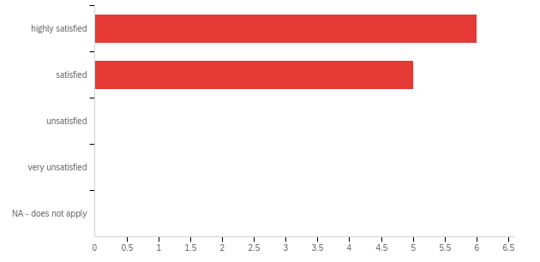

# | Field | Minimum | Maximum | Mean | Std Deviation | Variance | Count
1 | Ethical/legal decision-making skills | 1.00 | 2.00 | 1.45 | 0.50 | 0.25 | 11

# | Answer | % | Count
1 | highly satisfied | 54.55% | 6
2 | satisfied | 45.45% | 5
3 | unsatisfied | 0.00% | 0
4 | very unsatisfied | 0.00% | 0
5 | NA - does not apply | 0.00% | 0
 | Total | 100% | 11

Q16 - Self-care skills
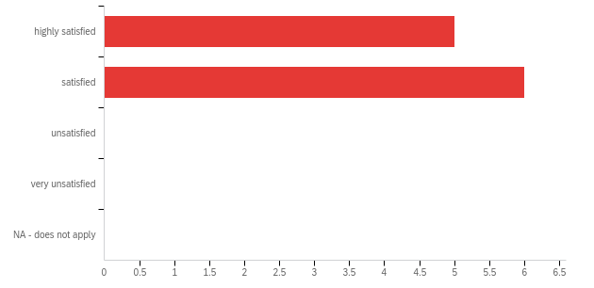

# | Field | Minimum | Maximum | Mean | Std Deviation | Variance | Count
1 | Self-care skills | 1.00 | 2.00 | 1.55 | 0.50 | 0.25 | 11

# | Answer | % | Count
1 | highly satisfied | 45.45% | 5
2 | satisfied | 54.55% | 6
3 | unsatisfied | 0.00% | 0
4 | very unsatisfied | 0.00% | 0
5 | NA - does not apply | 0.00% | 0
 | Total | 100% | 11

Q17 - Skills working in a school setting

# | Field | Minimum | Maximum | Mean | Std Deviation | Variance | Count
1 | Skills working in a school setting | 1.00 | 3.00 | 1.64 | 0.64 | 0.41 | 11

# | Answer | % | Count
1 | highly satisfied | 45.45% | 5
2 | satisfied | 45.45% | 5
3 | unsatisfied | 9.09% | 1
4 | very unsatisfied | 0.00% | 0
5 | NA - does not apply | 0.00% | 0
 | Total | 100% | 11

Q18 - Ethical/legal behavior
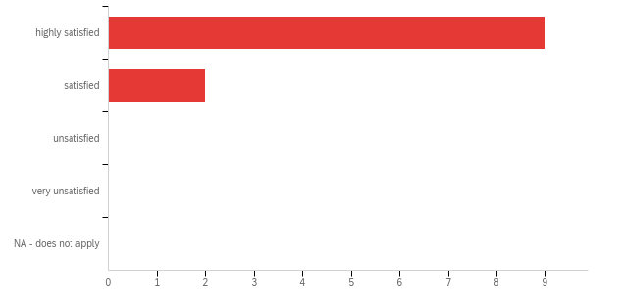

# | Field | Minimum | Maximum | Mean | Std Deviation | Variance | Count
1 | Ethical/legal behavior | 1.00 | 2.00 | 1.18 | 0.39 | 0.15 | 11

# | Answer | % | Count
1 | highly satisfied | 81.82% | 9
2 | satisfied | 18.18% | 2
3 | unsatisfied | 0.00% | 0
4 | very unsatisfied | 0.00% | 0
5 | NA - does not apply | 0.00% | 0
 | Total | 100% | 11

Q19 - Responsiveness to supervision, feedback, and/or suggestions

# | Field | Minimum | Maximum | Mean | Std Deviation | Variance | Count
1 | Responsiveness to supervision, feedback, and/or suggestions | 1.00 | 2.00 | 1.45 | 0.50 | 0.25 | 11

# | Answer | % | Count
1 | highly satisfied | 54.55% | 6
2 | satisfied | 45.45% | 5
3 | unsatisfied | 0.00% | 0
4 | very unsatisfied | 0.00% | 0
5 | NA - does not apply | 0.00% | 0
 | Total | 100% | 11

Q20 - Professional demeanor
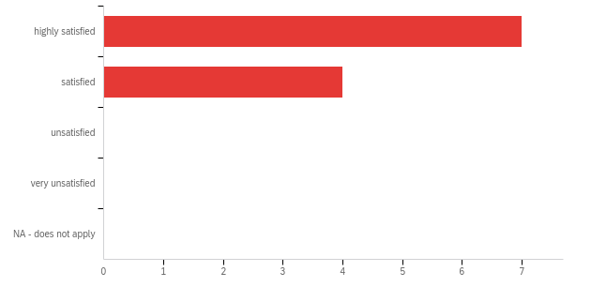

# | Field | Minimum | Maximum | Mean | Std Deviation | Variance | Count
1 | Professional demeanor | 1.00 | 2.00 | 1.36 | 0.48 | 0.23 | 11

# | Answer | % | Count
1 | highly satisfied | 63.64% | 7
2 | satisfied | 36.36% | 4
3 | unsatisfied | 0.00% | 0
4 | very unsatisfied | 0.00% | 0
5 | NA - does not apply | 0.00% | 0
 | Total | 100% | 11

Q21 - Relationships with other employees/coworkers
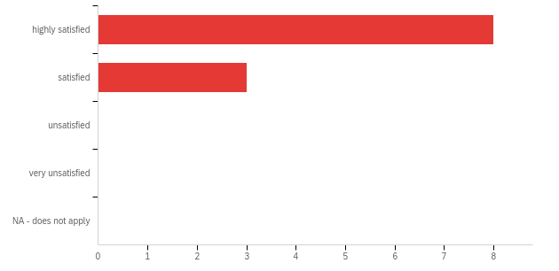

# | Field | Minimum | Maximum | Mean | Std Deviation | Variance | Count
1 | Relationships with other employees/coworkers | 1.00 | 2.00 | 1.27 | 0.45 | 0.20 | 11

# | Answer | % | Count
1 | highly satisfied | 72.73% | 8
2 | satisfied | 27.27% | 3
3 | unsatisfied | 0.00% | 0
4 | very unsatisfied | 0.00% | 0
5 | NA - does not apply | 0.00% | 0
 | Total | 100% | 11

Q22 - Collaboration with other school personnel/community agencies

# | Field | Minimum | Maximum | Mean | Std Deviation | Variance | Count
1 | Collaboration with other school personnel/community agencies | 1.00 | 2.00 | 1.36 | 0.48 | 0.23 | 11

# | Answer | % | Count
1 | highly satisfied | 63.64% | 7
2 | satisfied | 36.36% | 4
3 | unsatisfied | 0.00% | 0
4 | very unsatisfied | 0.00% | 0
5 | NA - does not apply | 0.00% | 0
 | Total | 100% | 11

Q23 - General work attitude/enthusiasm

# | Field | Minimum | Maximum | Mean | Std Deviation | Variance | Count
1 | General work attitude/enthusiasm | 1.00 | 2.00 | 1.27 | 0.45 | 0.20 | 11

# | Answer | % | Count
1 | highly satisfied | 72.73% | 8
2 | satisfied | 27.27% | 3
3 | unsatisfied | 0.00% | 0
4 | very unsatisfied | 0.00% | 0
5 | NA - does not apply | 0.00% | 0
 | Total | 100% | 11

Q24 - Dependability/conscientiousness/responsibility

# | Field | Minimum | Maximum | Mean | Std Deviation | Variance | Count
1 | Dependability/conscientiousness/responsibility | 1.00 | 2.00 | 1.18 | 0.39 | 0.15 | 11

# | Answer | % | Count
1 | highly satisfied | 81.82% | 9
2 | satisfied | 18.18% | 2
3 | unsatisfied | 0.00% | 0
4 | very unsatisfied | 0.00% | 0
5 | NA - does not apply | 0.00% | 0
 | Total | 100% | 11

Q25 - Professional development

# | Field | Minimum | Maximum | Mean | Std Deviation | Variance | Count
1 | Professional development | 1.00 | 2.00 | 1.64 | 0.48 | 0.23 | 11

# | Answer | % | Count
1 | highly satisfied | 36.36% | 4
2 | satisfied | 63.64% | 7
3 | unsatisfied | 0.00% | 0
4 | very unsatisfied | 0.00% | 0
5 | NA - does not apply | 0.00% | 0
 | Total | 100% | 11

Q26 - Student advocacy

# | Field | Minimum | Maximum | Mean | Std Deviation | Variance | Count
1 | Student advocacy | 1.00 | 2.00 | 1.36 | 0.48 | 0.23 | 11

# | Answer | % | Count
1 | highly satisfied | 63.64% | 7
2 | satisfied | 36.36% | 4
3 | unsatisfied | 0.00% | 0
4 | very unsatisfied | 0.00% | 0
5 | NA - does not apply | 0.00% | 0
 | Total | 100% | 11

Q27 - Leadership skills
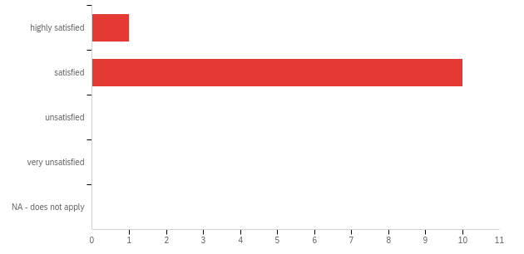

# | Field | Minimum | Maximum | Mean | Std Deviation | Variance | Count
1 | Leadership skills | 1.00 | 2.00 | 1.91 | 0.29 | 0.08 | 11

# | Answer | % | Count
1 | highly satisfied | 9.09% | 1
2 | satisfied | 90.91% | 10
3 | unsatisfied | 0.00% | 0
4 | very unsatisfied | 0.00% | 0
5 | NA - does not apply | 0.00% | 0
 | Total | 100% | 11

Q28 - What are the strengths of the IUPUI counseling/counseling education program?

What are the strengths of the IUPUI counseling/counseling education program?
Self-care/mindfulness; brain research with SEL; student advocacy
Our school counselor is very well-rounded and confident.
We have several graduates of the IUPUI program employed with our school. All had varying levels of knowledge and experience coming into our setting. All have very good problem solving skills and based on their level of experience, have adapted well to our school environment.
Content seems to be a strength.
Works well with staff, students and parents.
Counselor is a team player who works well under stress.
Overall, I've been very pleased with my counselor.
My counselor is a hard worker. She is very positive and enthusiastic. She is a good collaborator with other staff and other counselors in our district. Her classroom lessons are creative and engaging.

Q29 - Describe the areas of the program for which you recommend further growth or improvement.

Describe the areas of the program for which you recommend further growth or improvement.
N/A
N/A
Including a component related to working at an online school/virtual environment would be a great addition.
Data collection, research based strategies, ongoing PD opportunities.
Be more proactive in working with students in crisis.
Leadership and continued professional growth.
Classroom lessons and how to make them more student-interactive vs sit-and-get.
Continue to help counselors understand the resources that are available to help support our students' mental health issues, including anxiety and depression. Also, how to best support families in need of resources.

SC0 - Score

# | Field | Minimum | Maximum | Mean | Std Deviation | Variance | Count
1 | Score | 70.00 | 101.00 | 90.09 | 8.82 | 77.72 | 11

